Fikr Point of Sales

# Table of Contents

Contents

Table of Contents 1

Introduction 2

Prerequisites 2

Installation 2

Preparing prerequistes 2

Preparing database 2

Installing FikrPos Application 6

Running Setup.exe 6

Configuring database 7

Configuring Administration Account 10

Login to Application 11

Initialize company 11

How to use Fikr POS 12

Run FikrPOS as Admin 12

Run FikrPOS as Manager 14

Run FikrPOS as Cashier 15

# Introduction

This is still a preliminary documentation.

# Prerequisites

To use this application, you must have this prerequisite tools, which are:

1. Fikr Pos setup installer which can be downloaded from <http://fikrpos.swdevbali.com/Setup.exe> and Fikr Pos schema SQL which can be downloaded from <http://fikrpos.swdevbali.com/FikrPos.sql>
2. Microsoft.NET Framework 4.0, which already shipped with MS Windows 7, or can be downloaded from <http://www.microsoft.com/en-us/download/details.aspx?id=17851>
3. Microsoft SQL Server 2008 Express Edition, which can be downloaded from <http://download.microsoft.com/download/c/2/8/c28cc7df-c9d2-453b-9292-ae7d242dfeca/SQLEXPR_x86_ENU.exe>
4. Microsoft SQL Server Management Studio 2008 Express Edition, which can be downloaded from <http://download.microsoft.com/download/6/7/4/674A281B-84BF-4B49-848C-14873B22F977/SQLManagementStudio_x86_ENU.exe>

# Installation

## Preparing prerequistes

If all the prerequisites mention above alread been downloaded, you can proceed to install all of them. Just accept all the default value in installation process.

## Preparing database

With SQL Server 2008 Express and SQL Server Management Studio 2008 Express already installed, lunch SQL Server Management Studio 2008 Express to import FikrPos.sql, by following these screen steps:

1. Login to Management Studio  
   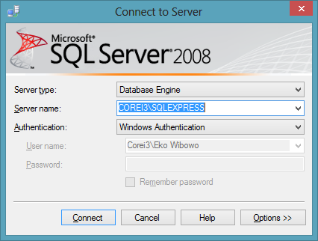
2. Open Databases node  
   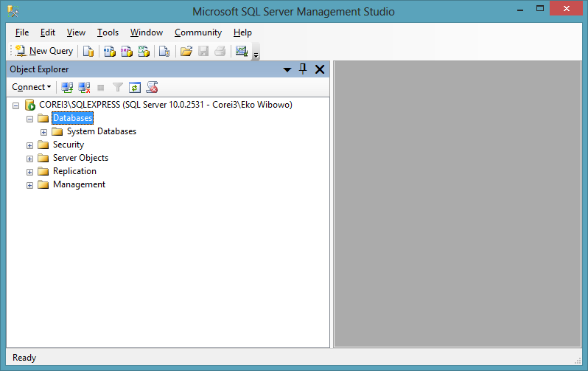
3. Right click on Databases node, and select New Database. You’ll see New Database dialog. Type FikrPos in the Database Name, and press OK.  
   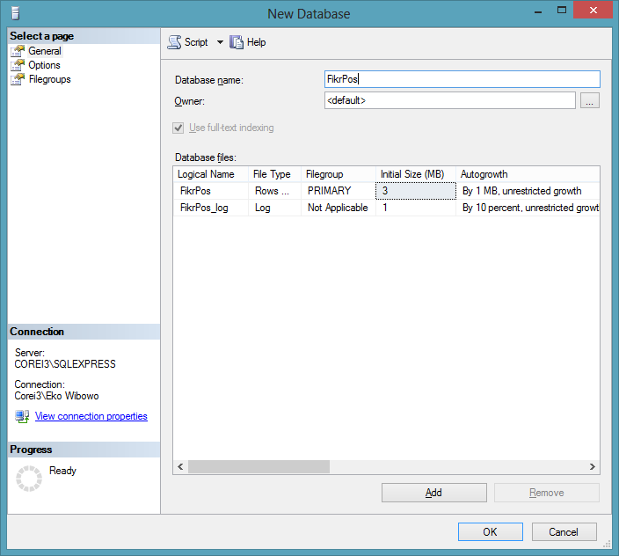
4. You’ll see FikrPos already listed in Databases node  
   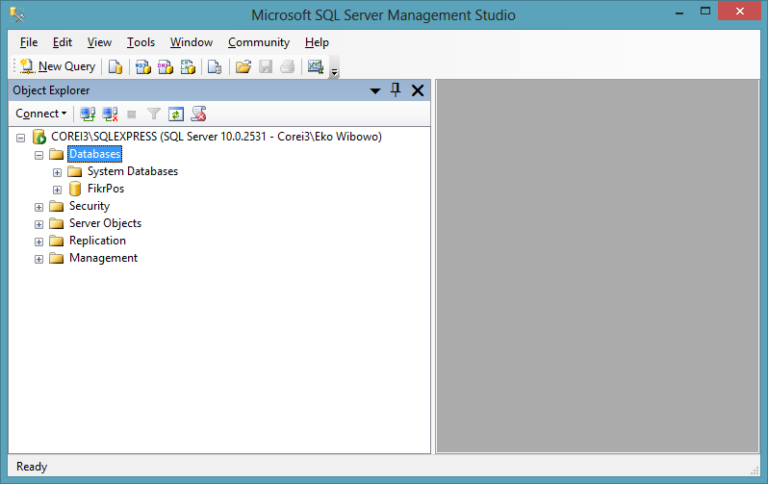
5. Now, right click on FikrPos database, and choose New Query. A blank query window is open. Klik Open File button and locate FikrPos.sql that you already downloaded.   
   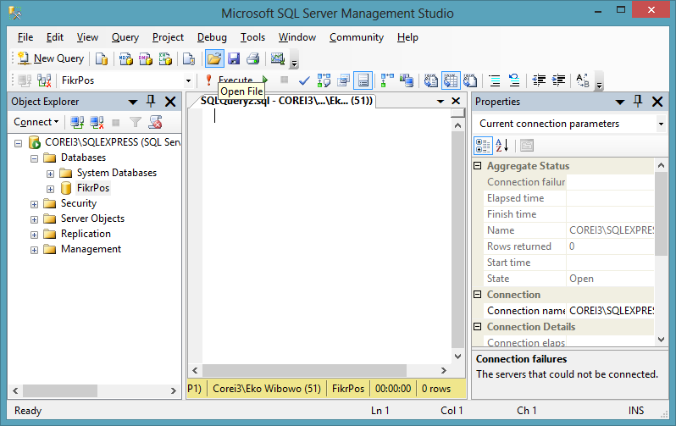
6. After FikrPos.sql is loaded, now press Execute button.  
   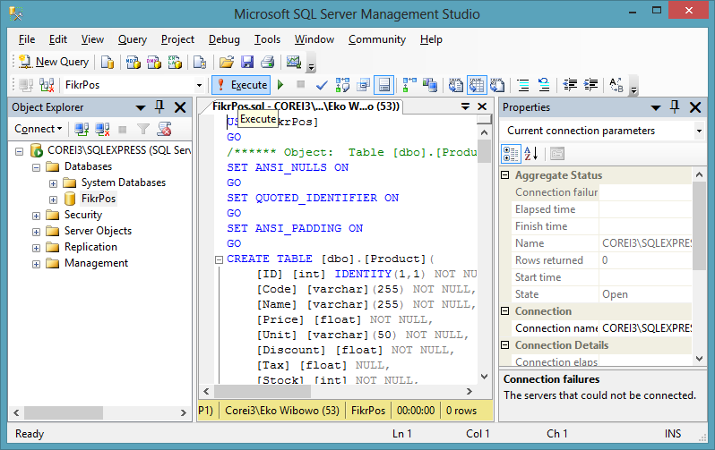
7. If everything goes well, now you can see all FikrPos tables as below:  
   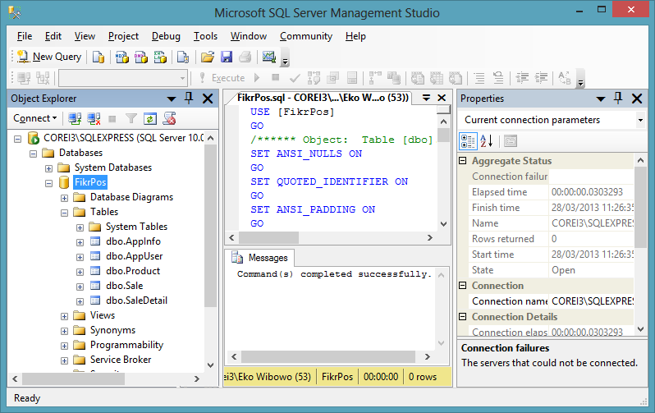

## Installing FikrPos Application

### Running Setup.exe

FikrPos application is distributed in single executable file named Setup.exe. Double click it, and you will be prompted with this installation window:

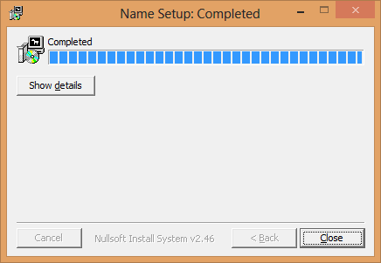

Press Close, and you can see FikrPOS in StartScreen (in Windows 8) or corresponding Start Menu in Windows 7 and below.

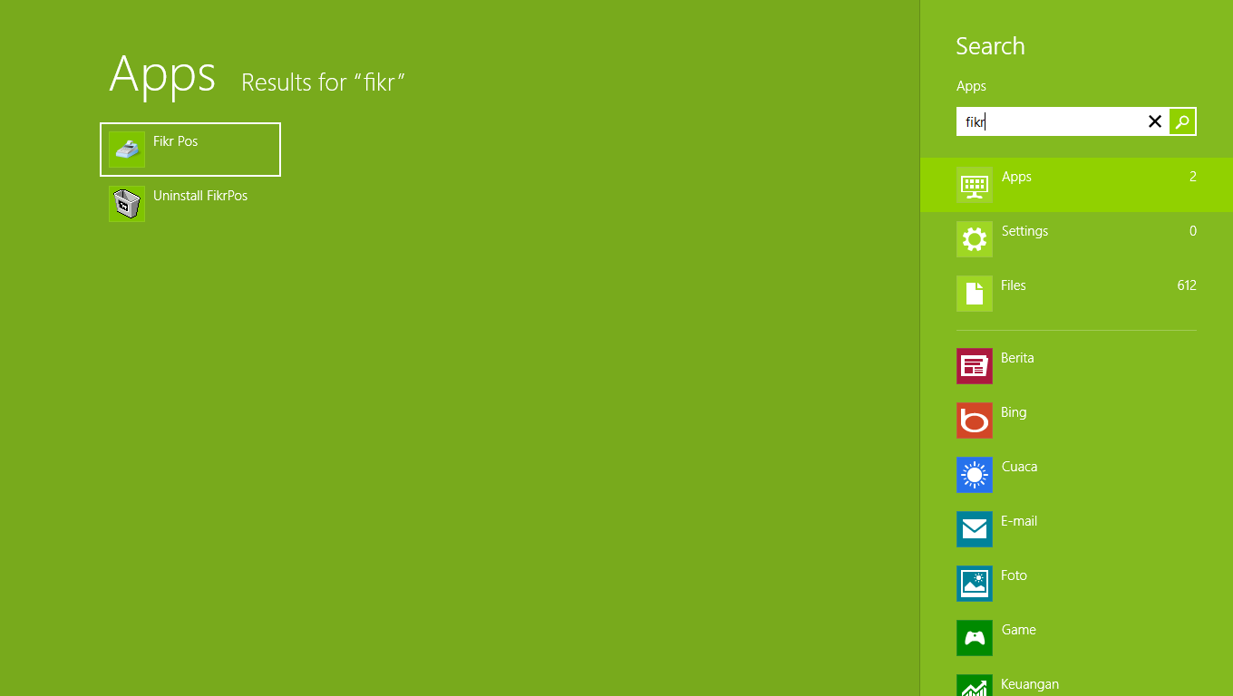

Click Fikr Pos.

### Configuring database

FikrPOS will detect that this is the first time you run this application, by showing you this window:

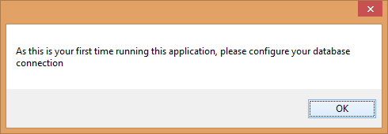

Press OK, and you will be prompted with Settings dialog box as shown below

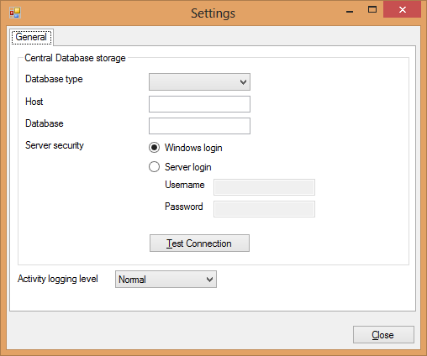

Fill with these values :

1. Database type : MSSQL Server
2. Host : localhost\sqlexpress
3. Database : fikrpos
4. Server security : Windows Login

Now press Test Connection. If all goes well, you will see this dialog box :

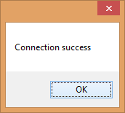

If not, such as you try to use remote server that currently didn’t have SQL Express installed, you will see this dialog:

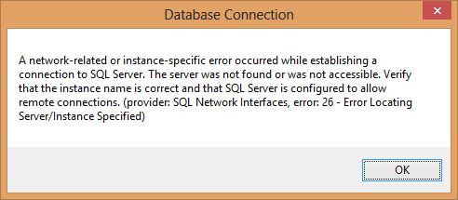

Or, if your database name is wrong, you will see this dialog :

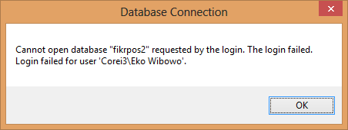

In summary, using the default values, you will setup Settings dialog as shown below:

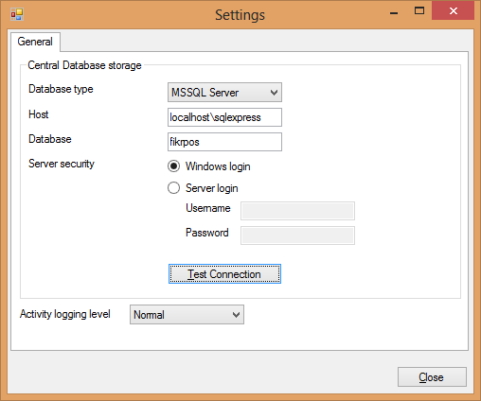

Prese Close, and you will be prompted with your administrator password.

### Configuring Administration Account

This application run in multiple user environment. To allow it to work properly, an administration account is needed. Give your admin username and password as below :

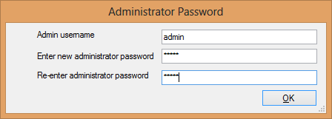

You are free to choose any username and password. Press OK, the application will give you hints of next step about login:

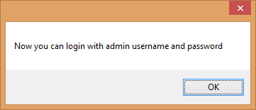

### Login to Application

Before using this application, you will be required to supply your username and password, shown below :

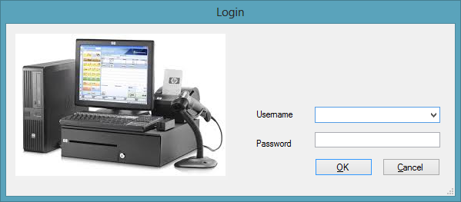

As now you already had admin username and password, entered it here. Press OK, and you will be directed to Main Window

### Initialize company

You will have to entered basic information about your company, at least give it company name and address.

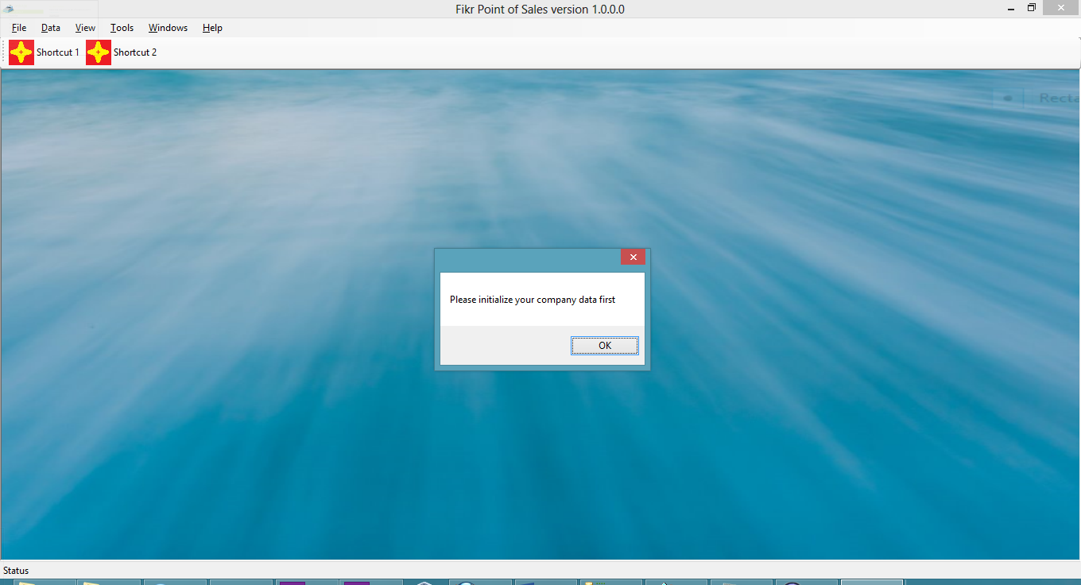

After giving these basic information, you can configure more detail information about your company:

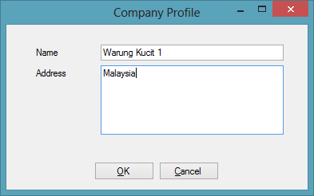

# How to use Fikr POS

Fikr POS will run based on its user role, which are :

* Admin
* Manager
* Cashier

## Run FikrPOS as Admin

* Add new user with role cashier, gives it proper name and password  
  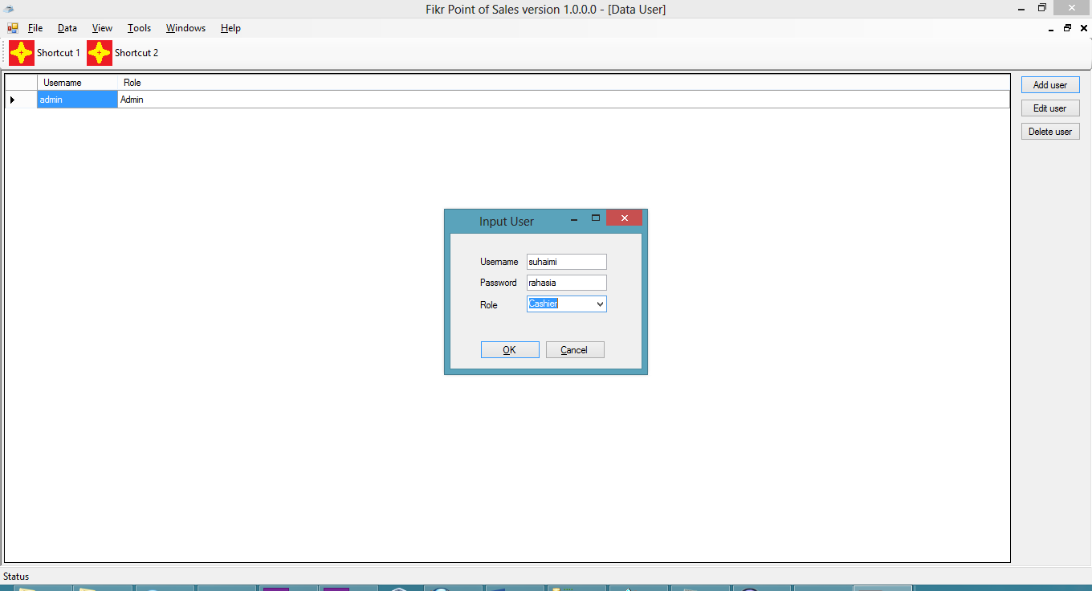  
    
  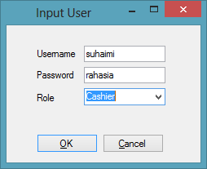
* add products that you will be tested in cashier module  
  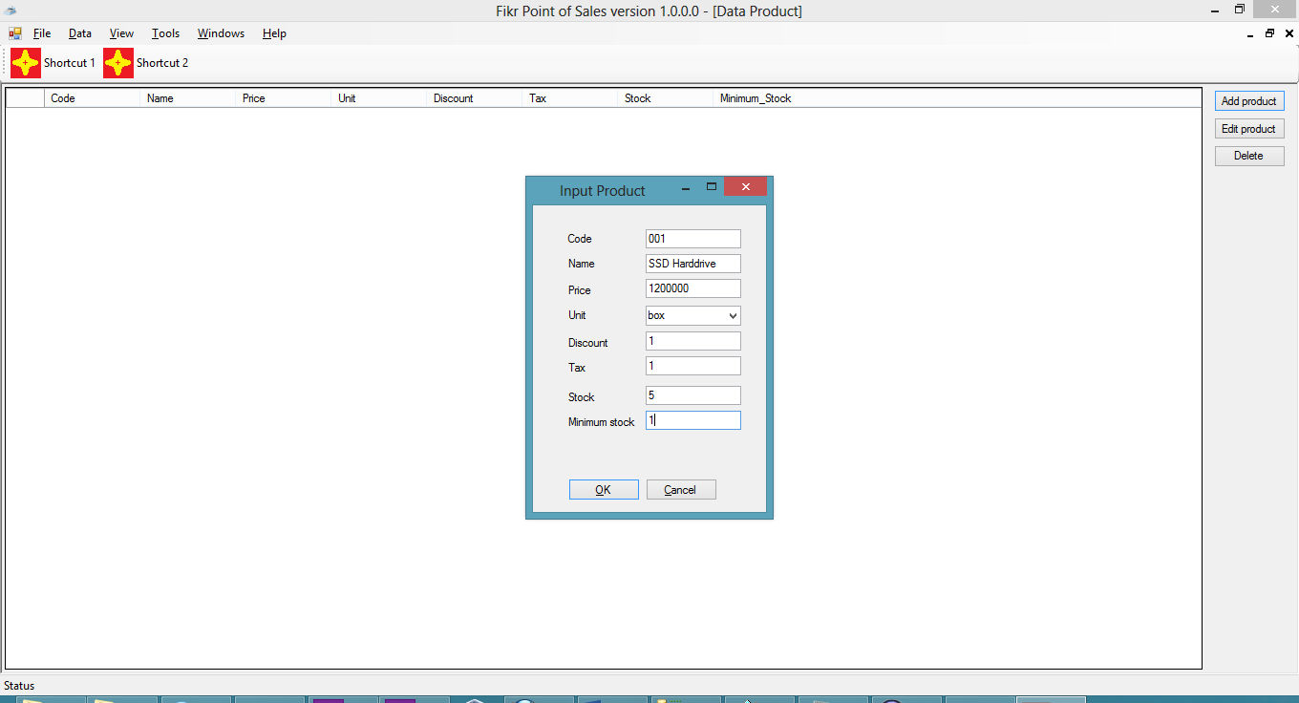  
  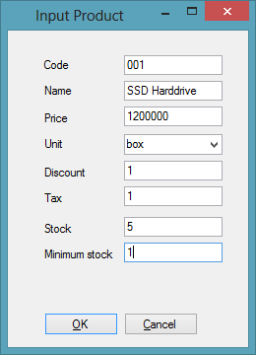
* Logout application and try to login using that cashier name and password

## Run FikrPOS as Manager

Not yet

## Run FikrPOS as Cashier

* Type the product code, press ENTER. It will runs out of the box using barcode scanner  
  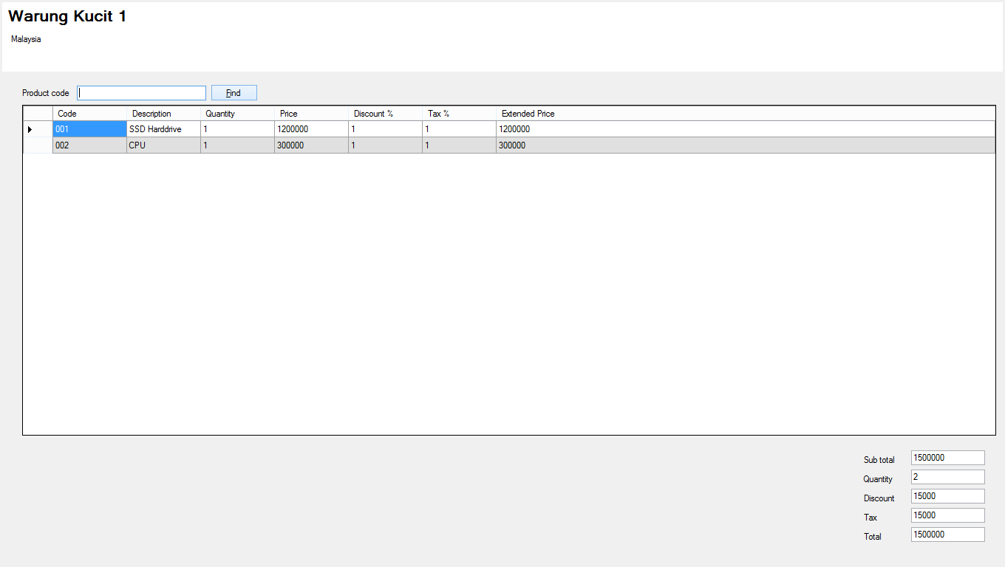
* If doubted about the product code, press F2 or click FIND. Double click its product name
* You can adjust quality by readding the product with the same product code, or just press DOWN arrow/use mouse to select the product Quantity that you want to change. Press UP arrow/F1 to go back to product code text box.
* Once everyting entered, press F12 to display payment dialog  
  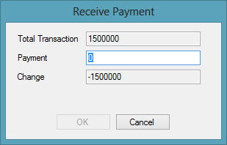  
    
  It will allows you to close the dialog once the payment is larger than the total transaction.  
  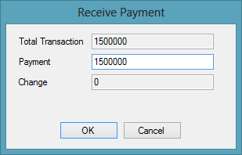  
  Press OK to close this transaction.